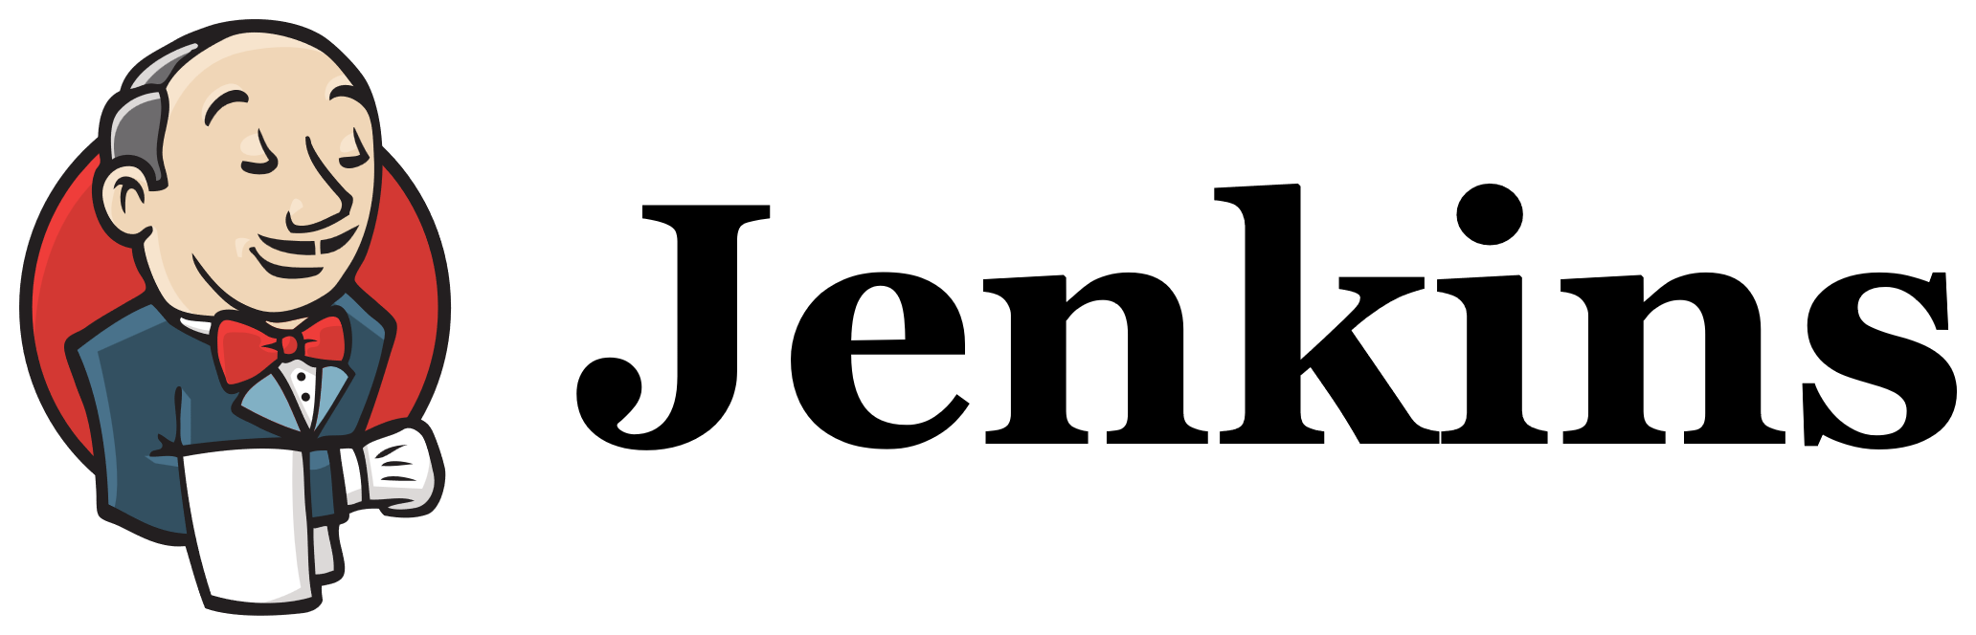
Title:
Task 2
Create one Jenkins job using the below code and create three stages:
- stage1: Git clone to download the source code.
- stage2: Sonarqube Integration to check the quality of code.
- stage3: Slack Integration to send the alerts to slack.
URL: https://github.com/betawins/hiring-app.git
Create a job in jenkins
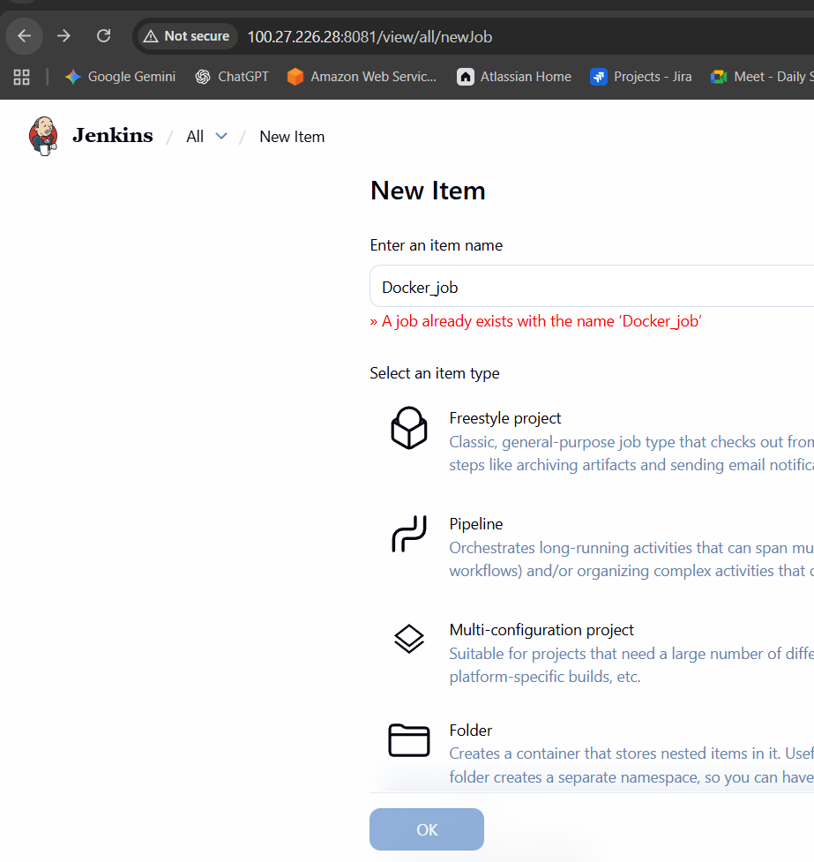

Provide description and continue
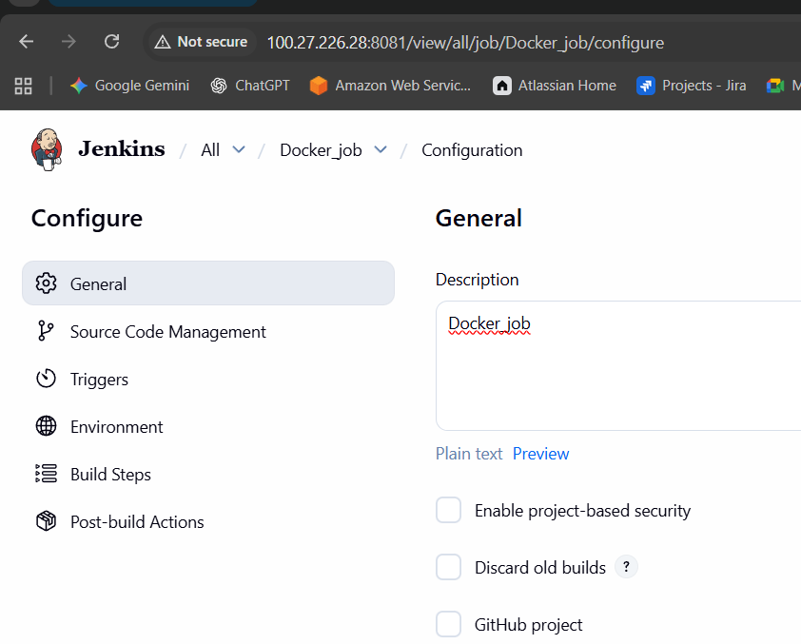
Provide the Git repo name.
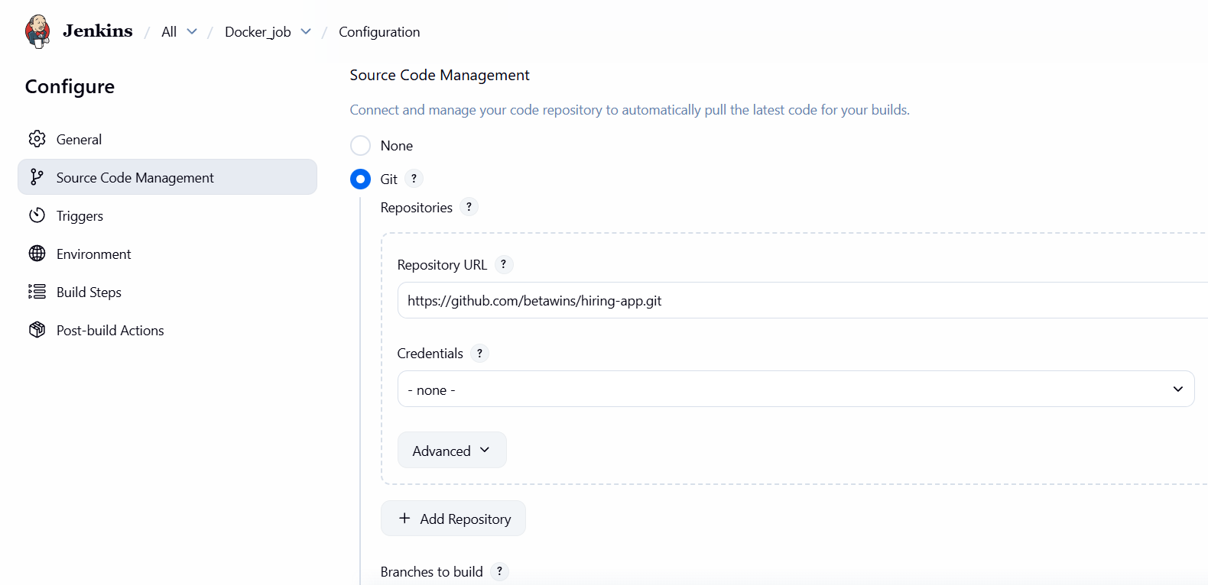

Add the details in analysis properties which available in repo
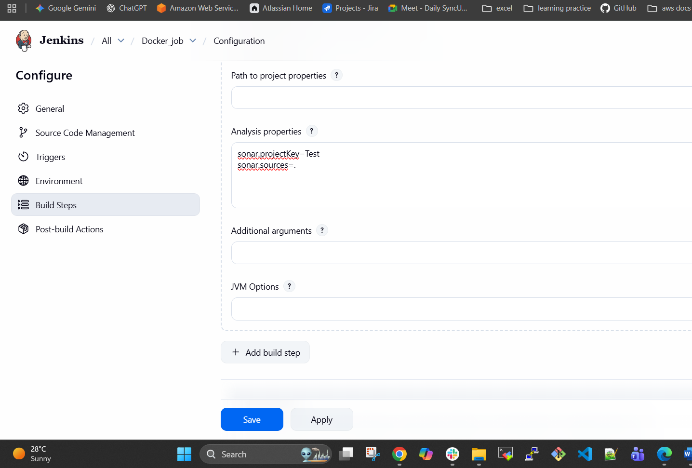
Enable slack notifications and continue
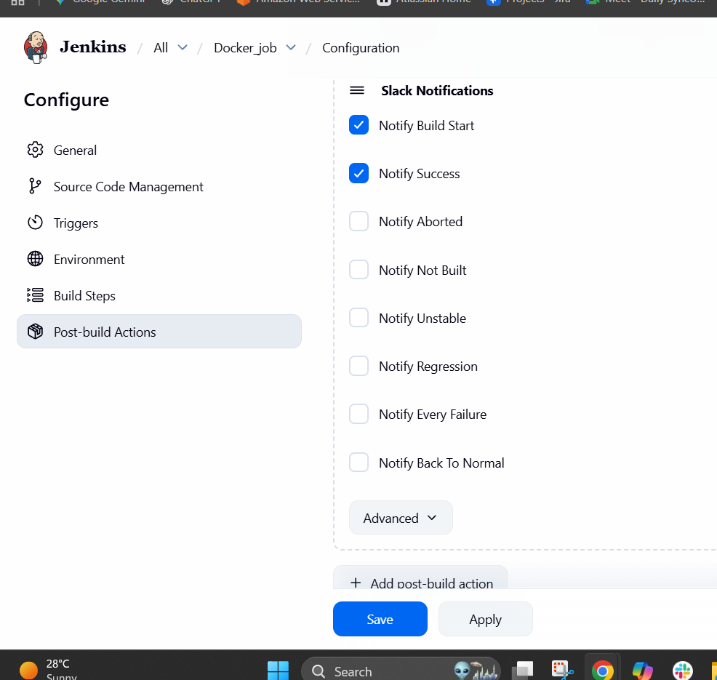
After saving the job was successfully created and will test
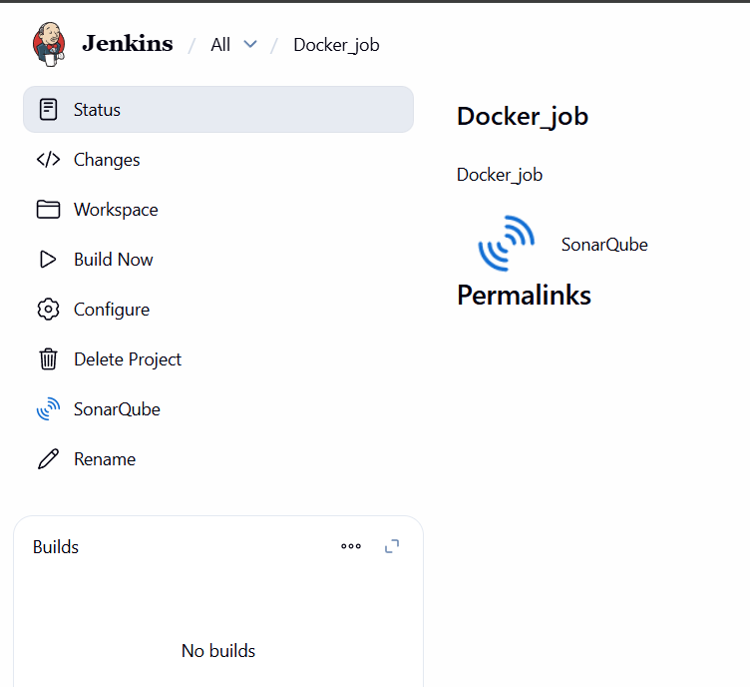
The build was executed but it was failed
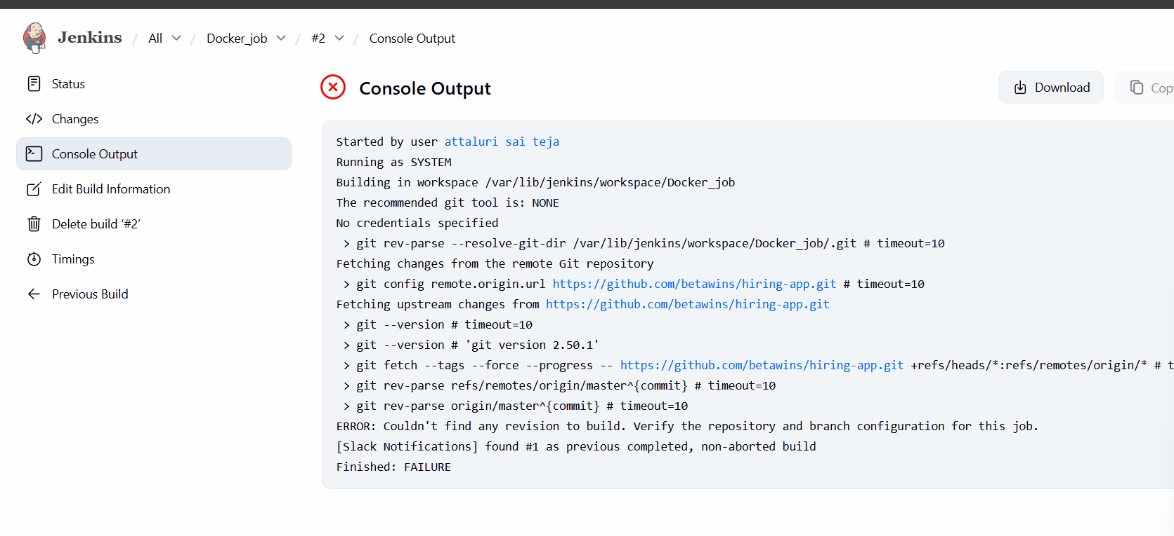
Steps to RESLOVE ISSUE
Changed the branch name to main from master.
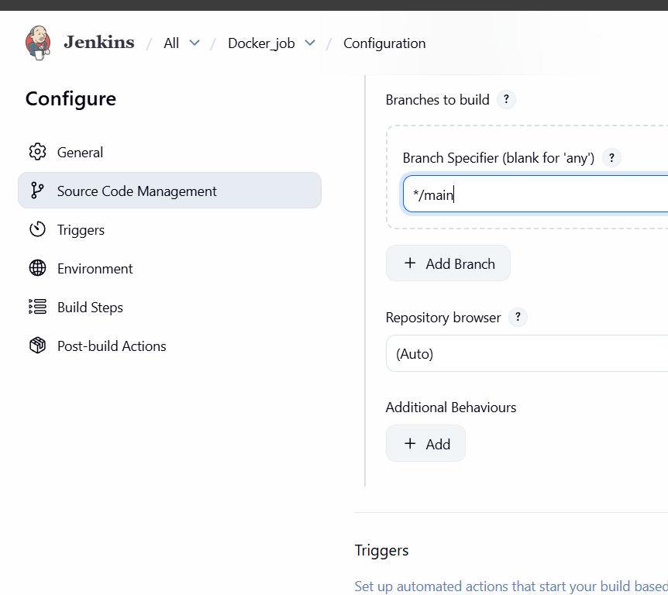

After REstarting the ec2 instance we need to update some details and need to integrate with Jenkins so that generate a token in sonarqube and copy it
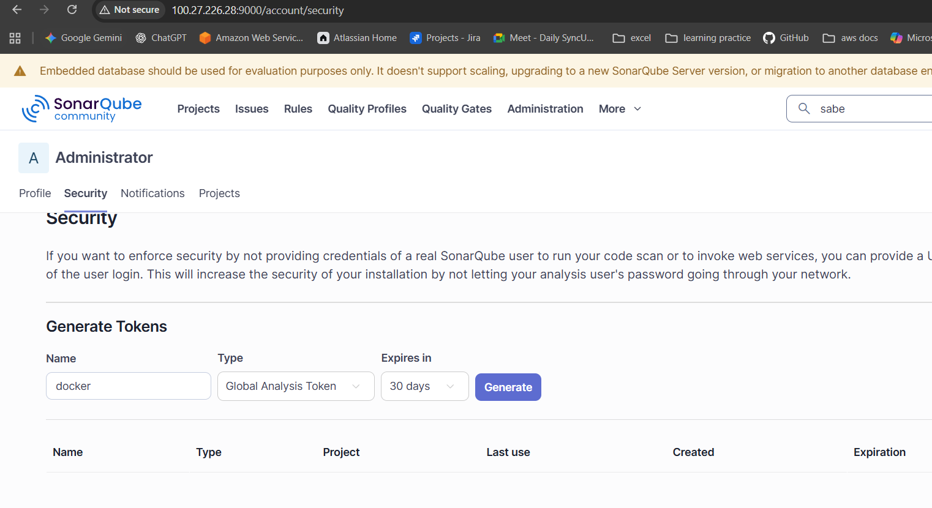
Pate the token in Credentials in Jenkins and continue by clicking on save
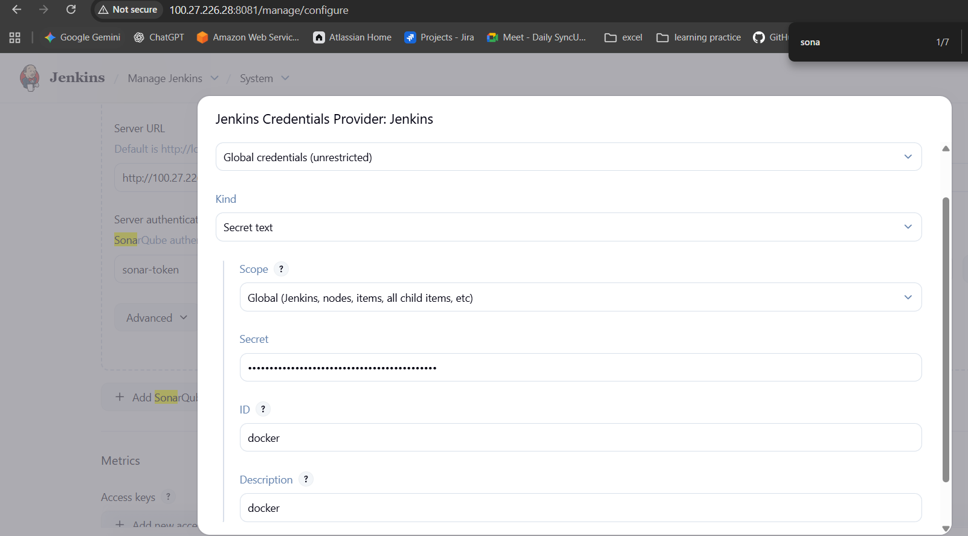

Also change the EXECUTE SHELL COMMANDS with new ip and new token
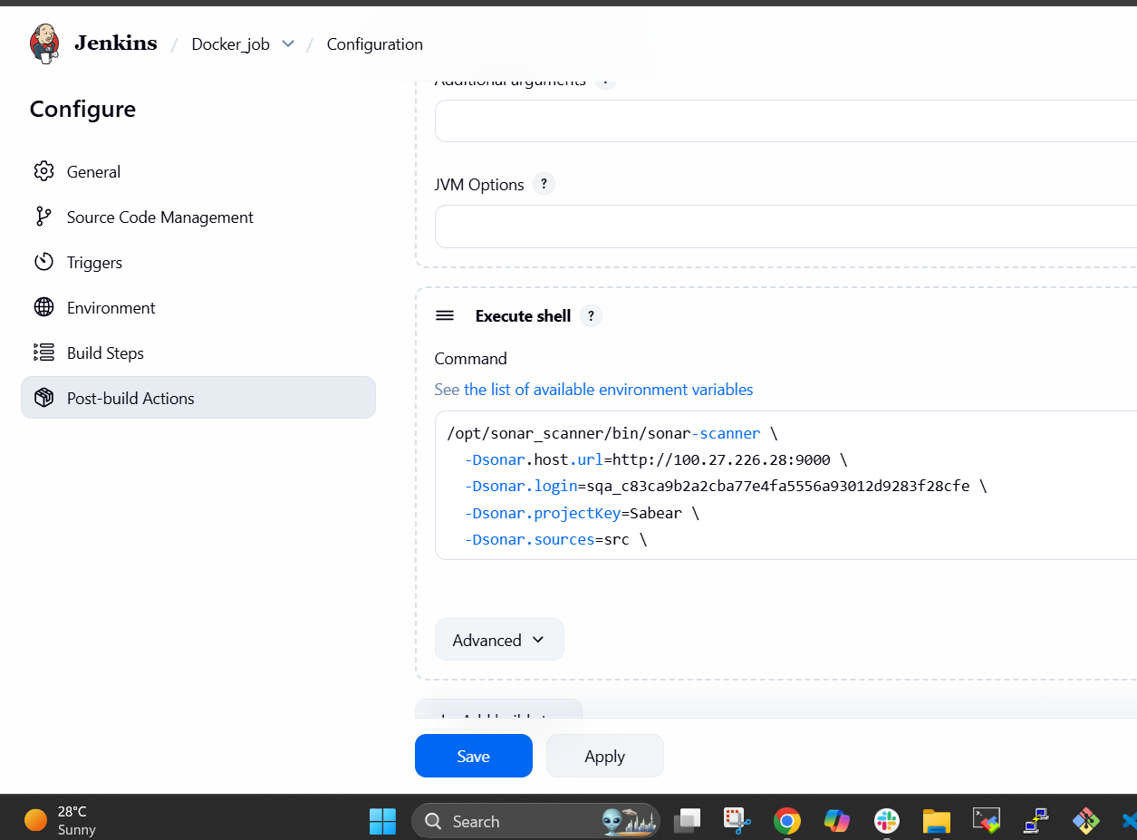
After saving again click on build and continue by verifying at SONARQUBE
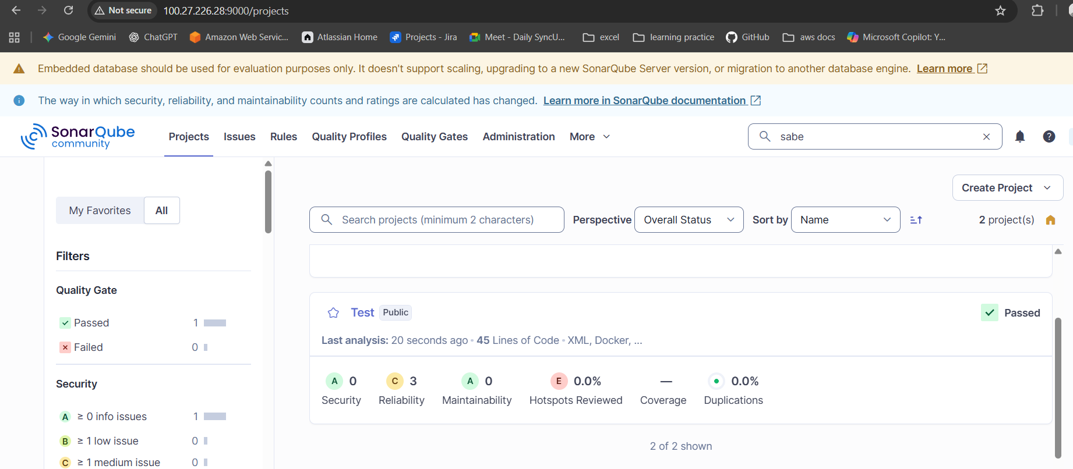

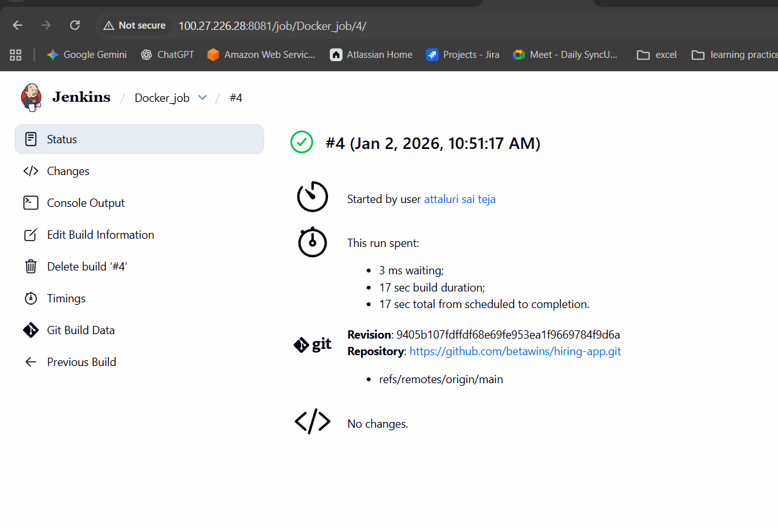
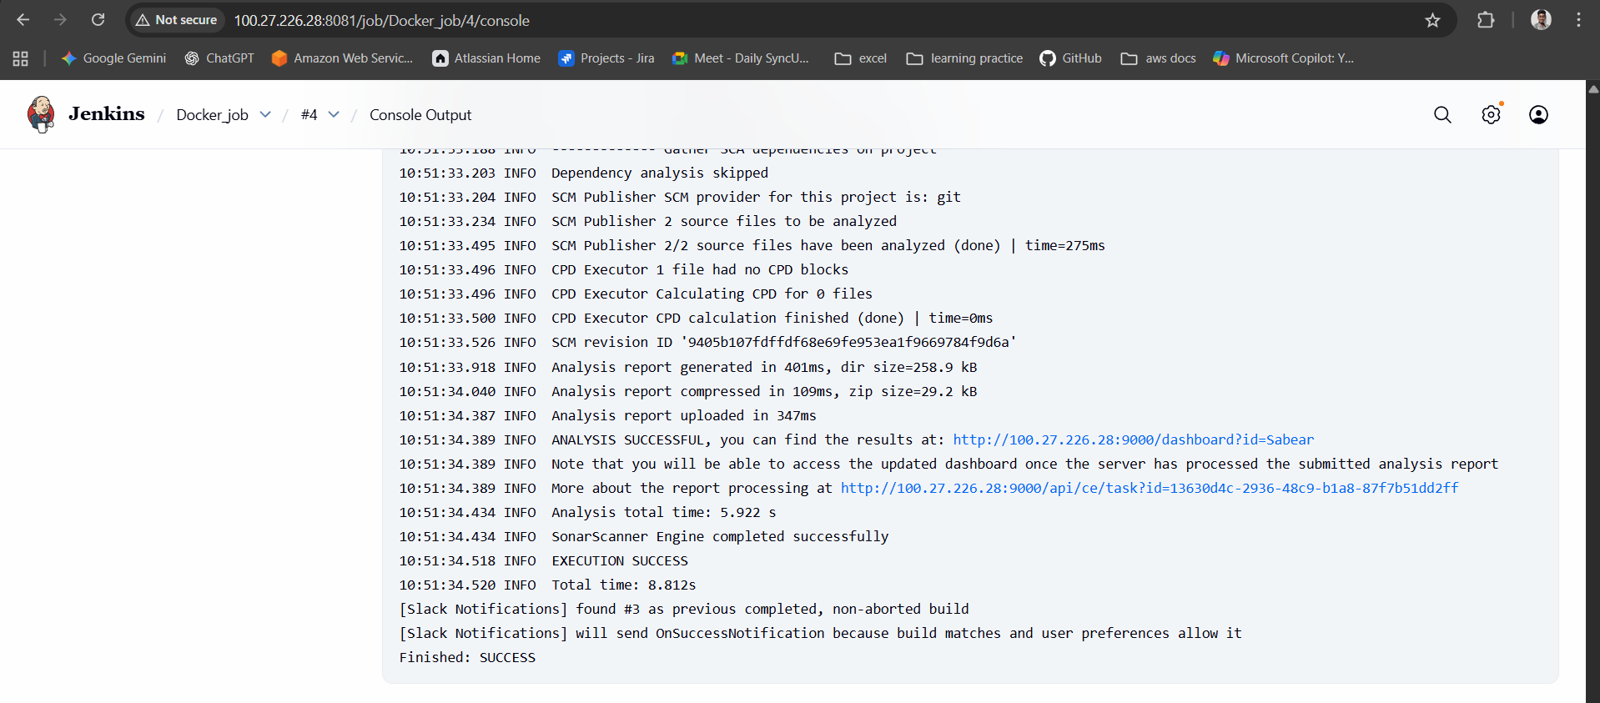

Also slack was integrated in build steps so that we can verify the notification in slack also
